Bahria University,

Karachi Campus



LAB EXPERIMENT NO.

___09___

LIST OF TASKS

|  |  |
| --- | --- |
| TASK NO | OBJECTIVE |
| **01** | Create a react application to build a greeting webpage having proper stylings with the help of React JavaScript code provided in the lab. |
| **02** | Write a code to create your personal portfolio webpage using the React JavaScript function component. |
| **03** | Write a code to create a basic arithmetic calculation application using the React JavaScript. |
|  |  |

Submitted On

28-12-2023

(Date: DD/MM/YY)

**Task 01:** Create a react application to build a greeting webpage having proper stylings with the help of React JavaScript code provided in the lab.

**Solution:**

**App.jsx**

import "./App.css";

function App() {return (<><div className="greeting-container"><h1>Welcome to My Greeting Webpage</h1><p>Enjoy your stay!</p></div></>);}export default App;

**App.css:**

.greeting-container {text-align: center;margin-top: 100px;}h1 {color: #3498db;}p {color: #555;font-size: 1.2em;}

**Task 02:** Write a code to create your personal portfolio webpage using the React JavaScript function component.

**Solution:**

**Header.jsx**

import React from 'react';const Header = () => {

return (<header><h1>Shoaib Akhter</h1><p>Web Developer</p></header>)};export default Header;

**Projects.jsx**

import React from 'react';const Projects = () => {

return (<section><h2>Projects</h2><h4>Quiz Application</h4><h4>MCQs Application</h4><h4>Password Management System</h4></section>);};export default Projects;

**Skills.jsx**

import React from 'react';const Skills = () => {return(<section><h2>Skills</h2><h4>HTML</h4><h4>CSS</h4><h4>JavaScript</h4><h4>React</h4></section>};export default Skills;

**Contact.jsx**

import React from 'react';const Contact = () => {return (<section><h2>Contact</h2><h4>This is my Contact Information</h4></section>);};export default Contact;

**App.jsx**

import React from 'react';import Header from './Header';import Projects from './Projects';import Skills from './Skills';import Contact from './Contact';import './App.css';

function App() {return (<div className="App"><Header /><Projects /><Skills /><Contact /></div>)}export default App;

**Output:**

**Task 03:** Write a code to create a basic arithmetic calculation application using the React JavaScript.

**Solution:**

import React,{useState} from 'react';import './App.css';

function App() {const [firstNumber,setFirstNumber]=useState(0);const [secondNumber,setSecondNumber]=useState(0);const [output,setOutput]=useState(0);const add=()=>{

return setOutput(Number(firstNumber) +Number(secondNumber))}const subtract=()=>{return setOutput(Number(firstNumber)-Number(secondNumber))}const multiplication=()=>{return setOutput(Number(firstNumber)*Number(secondNumber))}const division=()=>{return setOutput(Number(firstNumber)/Number(secondNumber))}return (<div className="App"><h1>Calculator</h1> <label htmlFor="firstDigit">Enter First Digit</label><input type="number" required onChange={(e)=>setFirstNumber(e.target.value)} id='firstDigit'/> <br />

<br /><label htmlFor="secondDigit">Enter Second Digit</label><input type="number" required onChange={(e)=>setSecondNumber(e.target.value)}   id='secondDigit'/> <br /> <br /><h4>What do you want?</h4><button onClick={add}>Add</button><button onClick={subtract}>Subtract</button><buttononClick={multiplication}>Multiplication</button><button onClick={division}>Division</button><h3>Output</h3><div>{output}</div></div>);}

export default App;

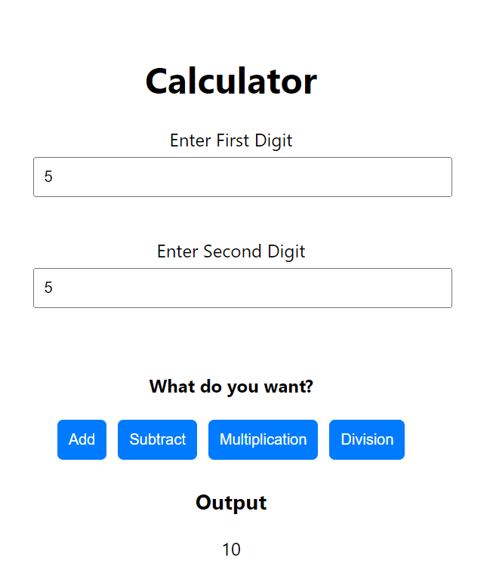**Output:**

